**Retail Rally**

*Game Design Document*

*Couch Competitive Non-Linear Sandbox Racing*

**Team Members & Roles:**

David Ducharme - *Coordinator, Game Designer*

Millie Harris - *Character Artist*

Andrew Sirkoch - *Environment Artist, Game Designer*

Greg Sirkoch - *Sound Designer, Game Designer*

Jack Palumbo - *Narrative Designer*

Hongyang Lin - *Programmer*

Jingyu Zhuang - *Programmer*

Jon Lafuente - *Programmer*

**Table of Contents**

**1.0 General Overview:** **4**

1.1 Common Questions: 4

What is the game? 4

Why create the game? 4

Where does the game take place? 4

What do I control? 5

How do I control it? 5

What do I see? 5

What is the main focus? 6

What’s different about this game? 6

What’s required to play? 6

**2.0 Walkthrough:** **7**

2.1 Phone-Computer Syncing Phase 7

2.2 Main Menu 7

2.3 Game Staging 7

2.4 Playing the Game 8

**3.0 Features Breakdown** **9**

3.1 Phone to Computer Session Connectivity 9

3.2 Split-Screen Functionality and Requirements 9

3.3 Level Randomization 9

3.4 Unlockable Content 10

**4.0 Mechanics Breakdown** **11**

4.1 Scoring & Checking Out 11

4.2 Driving 12

4.3 Picking Up Items 12

4.4 Using Items 12

-Item Functions- 13

4.4.1 Throwable Items 13

4.4.2 Placeable Items 13

4.4.3 Phone Based Items (Sending Calls) 13

4.4.4 Powerup Items 14

4.5 Losing Items 14

4.6 Falling Out Of Your Cart 14

4.7 Shopping Cart Stats 15

4.8 Store Robots 15

**5.0 Aesthetics Breakdown:** **16**

5.1 Character Design 16

5.2 Environment Design 16

5.3 Product Design 16

5.4 UI Visual Design 16

5.5 Sound Design 17

5.6 Music Composition 17

5.7 Dialogue 17

5.8 Level Design

**6.0 References/Lists:** **18**

6.1 Product Name & Usage List: 18

6.2 Unique Usable Items Functionality List: 21

6.3 Shopping Carts List: 22

6.4 Character Models, Names, and Descriptions List: 25

6.5 Achievements List: 26

6.6 Tutorial Objectives List:

# **1.0 General Overview:**

## *1.1 Common Questions:*

### **What is the game?**

Retail Rally is a four player couch competitive shopping game. Players race to complete their shopping list while simultaneously dealing with obstacles imposed by other players in a non-linear sandbox supermarket. Players additionally must download the corresponding Retail Rally app, and connect their personal devices to the game session in order to gain access to features such as private shopping lists, and a GPS store navigator.

### **Why create the game?**

Retail Rally provides a unique cross-platform party game experience like no other, while simultaneously painting a dystopian future that doesn’t seem all too unbelievable. Through humor and sarcasm, Retail Rally makes light social commentary on issues such as consumerism, public health, and work-force automation.

### **Where does the game take place?**

Retail Rally takes place in a mildly dystopian and not-too-far-in-the-future American society. In this society, every Sunday is Sales Sunday, where all the large retailers put on heart-stopping deals. Sales Sunday can be likened to Black Friday, except it happens every week instead of once a year.

The play space is inside of a store, varying in size based on the level chosen. With each play-through, the store’s color scheme and signage is randomized to visually represent a different store.

### **What do I control?**

Players control their own character avatar, which is driving a motorized shopping cart. They additionally must control their phone to an extent, using it to navigate the store and skillfully avoiding robo-callers.

### **How do I control it?**

Players use console controllers to control their avatars, with typical racing controls (throttle, brakes, drifting). To pick items up the player uses the right analog stick to point an arrow around their cart. Then, the player presses a button to put the item that is being pointed at into their cart. A list of usable items (these items are not items that are required to win) appear at the top of the players screen in a list format. The player can use the directional buttons to scroll through the list. The player then uses the R1 button to perform an action with the selected item from the list.

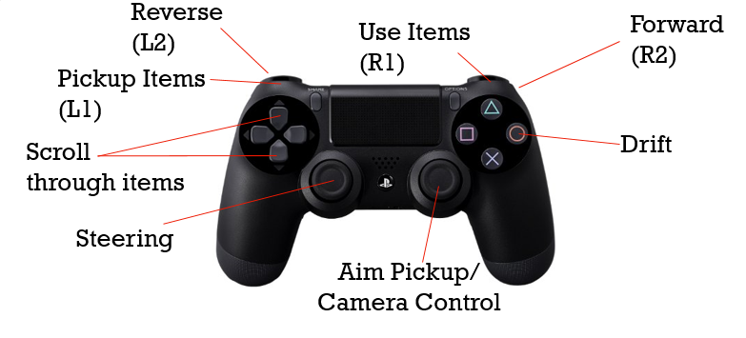

### **What do I see?**

The players see their avatar from a 3rd person point of view. The camera is behind the player and raised slightly so the angle looking slightly down. There is a list that always displays in the corners of the screen (top left player’s list is in the top left of their quadrant). This list displays the inventory of the players shopping cart. On each player's phone the list of items that they need to get for Sales Sunday is displayed as well as a RADAR style navigator to show where the items are in relation to the player.

### **What is the main focus?**

Each player aims to collect their items faster than the other players. This can be achieved by sheer speed of collection, deliberate destruction of other players or a happy combination of both.

### **What’s different about this game?**

The most obvious part about this game that makes it stand out from the crowd is the use of the phone to conceal information in a split screen game. The game is also a non-linear racing game that doesn’t take place on the standard racing track. It uses a grid of tracks by taking place in a supermarket.

### **What’s required to play?**

* A computer with internet access
* Each player needs their own smartphone with the ability to connect to the same wifi source as the computer that is running the game.
  + Access to the Retail Rally app
* Each player needs their own controller, that is USB connectable to the computer.
  + Potentially a USB splitter for computers with a low amount of USB slots.

# **2.0 Walkthrough:**

*A description of the play experience, from beginning to end.*

## *2.1 Phone-Computer Syncing Phase*

Upon booting the game on the computer, players are prompted to download the Retail Rally App with the grocery list and map features. Once the app is downloaded, players can connect to the computer that is hosting the game session, and will enter a name. This name then appears on the computer screen, where each player selects their name with their corresponding controller. Players cannot proceed from this step until at least one player connects and syncs their controller to their name.

## *2.2 Main Menu*

Upon completing the set-up phase, players are greeted by the main menu, which takes the form of a conveyor belt. Boxes with the main menu navigable actions (Play, Unlockables, Options, Quit) are moving from right to left. Players control a handheld price scanner, which can be moved in the horizontal and vertical axis by using the left analog. Pressing the X button will cause the price scanner to scan, emitting a red light and a beep noise, and selecting whichever box falls under the scanner, thus navigating between the menus.

An additional menu within the main menu is the unlockables screen, where players are presented with a list of unique tasks that upon completion result in additional content, such as more character models, more shoppings carts, and more maps. This is discussed further in 3.0 Features Breakdown.

## *2.3 Game Staging*

When players select to Play from the Main Menu, the camera will swivel to turn and look at a computer screen. This is the staging screen. It is split into four sections, one for each player, where they choose their character model (purely cosmetic) and their shopping cart. Shopping carts have varying stats, leading towards different play styles for players, which is detailed further in *3.0 Features*. Once all players have selected their character and cart, an overlay appears where players are to select the map for this playthrough. This begins the game.

## *2.4 Playing the Game*

Upon loading the selected map, a cinematic camera moves through the level, giving the players an overview of the level’s layout. This cutscene can be skipped for experienced players. Players can notice now that their phone has transitioned scenes, and now contains a GPS navigator and their grocery list. An announcer announces that the store will be closing in X minutes, and a timer will appear at the center of the screen. Players are then placed at the entrance of the level, side by side, awaiting a countdown before beginning. Once the countdown expires, the gameplay begins and players are free to race throughout the store. Players have this allotted amount of time to scour the store for their products.

After a certain amount of time passes, or once one player makes sufficient progress in their list, a Speedy-Sale event will occur, placing a single bonus score item on everybody’s list, but only one of these items spawn in the store.

Once a player is satisfied with what is in their cart, they can finish the level by leaving the store where they began, marked by the large EXIT sign. Failing to leave the store by the time limit will result in a score reduction, while leaving with time remaining results in a score bonus.

# **3.0 Features Breakdown**

## *3.1 Phone to Computer Session Connectivity*

The game uses TcpClient class from C# .NET to setup the server. At the start of each game a TCP server will be launched under the current local network of the PC. Cellphone clients, as the TCP Client, will auto detect the local server and connect to it.

## *3.2 Split-Screen Functionality and Requirements*

Retail Rally is playable with up to four players on one computer. This is possible only if four individual controllers are connected, which might cause some issues to arise for the standard consumer. Smaller machines such as laptops often do not have enough USB ports to support four controllers, but this issue can be remedied with the purchase of a USB splitter.

PS4 controllers are currently the only supported controller type, but there are plans to build in support for other controllers as well as the development cycle continues.

## *3.3 Level Randomization*

Each level is split into eleven sections, or categories, with each of these sections being notated by an overhead sign with an icon.

These sections are randomly assigned with each playthrough, ensuring products are never in the same place twice. Each section contains a number of shelves, with each shelf unit containing one product type. Product location within each section is randomized as well. Each section has a minimum of six unique products to that section. A list of products by section can be found at *6.1 Product List.*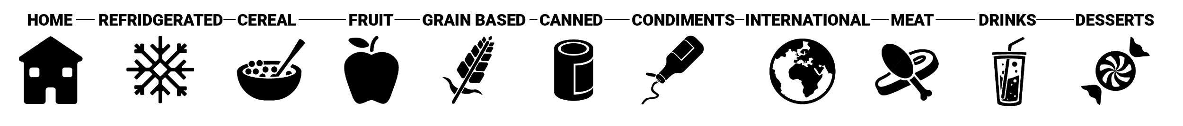

The store’s color scheme and brand signage is additionally randomly decided from a list of available templates. This results in a visually different store for each playthrough.

## *3.4 Unlockable Content*

Retail Rally contains unlockable content which can be achieved through certain feats of gameplay. Most of the unlockable content in the game is presented to the player upon the accomplishment of an achievement. Unlockable content consists of…

* Additional Characters (cosmetic purpose only)
* Additional Shopping Carts (with varying stats)
* Maps (with varying sizes/layouts)

# **4.0 Mechanics Breakdown**

## *4.1 Scoring & Checking Out*

Scoring is based on three criteria:

* Amount of time it takes to shop and then exit the level.
  + *The game runs on a stopwatch, which doesn’t determine the length of the game but rather a score modifier for each sales sunday item the player purchases. The earlier you purchase a sales sunday item, the higher the score modifier for purchasing that item will be. As the game runs, the score modifier decreases at a constant rate.*
* Number of items bought that were on the player’s shopping list.
  + *Players gain extra score for each item bought that was on their shopping list, and lose score for each item that was on their shopping list but was not bought.*
* Number of items bought that were not on the players shopping list.
  + *Players are penalized for purchasing items that were not on their shopping list. This leads to an extra phase of players having to purge their carts of unnecessary items before checking out.*

The checking out process begins whenever players enter the checkout area of the store, which is marked by a large “Checkout” sign. Players drive up to the front of the counter into the illuminated circular checkout zone to begin the checkout process. Items are one by one transported from the cart to the conveyor belt, with each item taking a short amount of time to be placed on the conveyor belt, denoted by a circular icon of the item and a progress bar around that icon being placed above the player’s head. Items move along the conveyor belt until they enter a small chute that exits the building. Once the item enters the chute, it is purchased and calculated towards the player’s score.

## *4.2 Driving*

Driving is fairly standard carting controls. Holding the R2 button accelerates the cart until the cart is at max speed, then the cart will stay at max speed until the R2 button is released. L2 is the brake and will decelerate the cart when held. Past the stationary position L2 will cause the cart to go backwards. The left analog controls the turning of the cart (left and right). Holding the O (circle) button will cause the cart to enter drift mode which causes the cart to slide and turn the direction that the left analog is facing.

## *4.3 Picking Up Items*

Using the right analog, players can cast an arrow out from their player’s position, rotating around the player on the Y axis, based on analog position. The closest object/shelf in relation to the player that is within the arrow’s area of influence gets highlighted for potential pickup. Upon pressing the L1 mapping (front left bumper) the highlighted object will be picked up and placed within the player’s cart (if there is sufficient space). The more items in the player’s cart will linearly increase the cart’s mass and decrease the cart’s toughness value.

## *4.4 Using Items*

In the corner of each player’s quadrant, they have a UI widget that represents their inventory of usable items. Not all items that are within the player’s cart appear in this interface, as any items in the player’s cart that are on their Sales Sunday list are NOT usable. This is to prevent players from accidentally losing some of their win condition items. Players use the up and down arrows on the D-Pad to navigate through their usable items.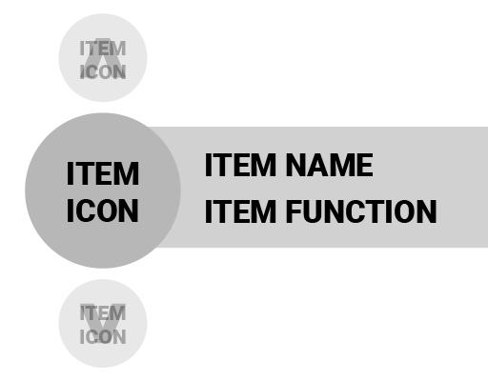

Pressing and holding R1 (front right bumper) will then enter the item use mode, which will temporarily change the functionality of a control scheme, depending on the function of the selected item. These functions are discussed one by one below:

## **-Item Functions-**

### *4.4.1 Throwable Items*

Pressing and holding R1 with a throwable item selected with enter item throw mode. Item throw mode temporarily replaces the right analog stick’s functionality from being an item pickup function, to being an aiming system. The player’s character model will enter a throwing pose, where a parabolic arc will be cast out from the player’s hand location. Using the right analog, players can aim where the end of this arc hits the ground by moving the analog left and right to rotate, and up and down to change distance. Releasing R1 will send the item flying along the parabolic arc, similar to grenade throwing in many FPS games.

A large majority of throwable items will result in a puddle being spawned at the place of contact. These puddles can have various effects

### *4.4.2 Placeable Items*

The aiming system for placeable items is identical to throwable items, with the exception of the player’s range being reduced. Additionally, upon the thrown item hitting the ground, it will destroy itself and then spawn another object at place of contact. These items are used to create roadblocks for your opponents

### *4.4.3 Phone Based Items (Sending Calls)*

Pressing R1 with a phone based item will not seem to do anything initially, but players will soon realize that this replaces their phone’s shopping list and GPS with a contact list, with each contact being their opponent’s player names. Players can select one of the contacts to send a robo-call to that opponent, which temporarily disables their opponents’ phone interface.

### *4.4.4 Powerup Items*

Upon the player’s tap of R1 with a Powerup Item, the user will gain a temporary advantage in the form of a buff. These items differentiate from the other use items that aim at deterring other players. Some examples of buffs given to the player through the use of a Powerup item include speed boosts, or the ability to temporarily prevent items from flying out of your cart. Buffs from Powerup Items last for a definite amount of time, and are notated by an icon with a circular progress bar, representing the amount of time left for the currently active powerup.

## *4.5 Losing Items*

Players are able to lose items out of their cart if they take part in a collision that is of high enough speed, or if their cart rotates past a certain threshold. Once these conditions are met, the quantity of items lost is then determined based off of speed of collision (if a collision causes the loss of items). If the player loses items due to the cart tipping, ⅓ of the player’s items are lost. The items that are selected to be lost are then ejected from the cart and sent upwards into the air. At all moments of the game except for during the above conditions, the player’s cart is unable to lose items.

## *4.6 Falling Out Of Your Cart*

A couple of things could cause the player to fall out of their cart, such as their cart becoming rotated past a threshold or getting hit by a projectile. As the player is triggered to fall out of their cart, their player avatar becomes under the effects of the physics system, turned into a ragdoll, and gets launched in a direction. The player gets back to the cart by mashing a button which pathfinds the player back to the downed cart. Once the player gets close enough to the cart, the cart will reset back to its original upward and drivable position.

## *4.7 Shopping Cart Stats*

Different carts have different stats that affect gameplay. These stats include:

Basket Size - how many items the player controlling the cart can hold in their inventory.

Speed - the max speed of the vehicle

Acceleration - how fast the cart gets up to speed

Toughness - the threshold it takes for the cart to fall over and the player to fall out, and the mass of the cart, which determines the priority and strength of the cart in collisions.

Drift - The slipperiness of the cart in drift mode

## *4.8 Store Robots*

Cleaning Robot - Takes up a whole aisle and players are not able to pass it (unless a powerup allows). The robot will wander around on a predefined path unless a player has activates a powerup that causes a mess. The robot will then go to the mess and clean up the mess. Upon cleaning up the mess, the robot will return to its predefined path.

Assistant/Restocker Robot - Will wander around and pick up items that are on the ground and throw them away (or restock them in their proper spot) The player can run into the robot to drop their item. The robot will announce spills and other voicelines.

# **5.0 Aesthetics Breakdown:**

## *5.1 Character Design*

The character design is a cartoon style with a light hearted and happy feel to it. They all have unique outfits to make them stand out amongst one another so that players can have plenty of variety in the way their player looks. Different outfits, hairstyles, and skin types will be unlocked by players as they complete achievements. Every Character has a customizable outfit, with players being able to customize their character’s shirt, pants, and hat.

The helper robots will be of very friendly demeanor with a sleek metallic design to emphasize the futuristic setting of the game. Yet still maintaining the friendly look and feel with a facial monitor displaying their emotions as cute cartoon smiles or frowns.

## *5.2 Environment Design*

While the majority of the game is full of bright colors, the environment design is the exception. The environment (the building structure, shelving units, etc.) is intentionally on the drabber side. This adds a visual clarity to the game as a whole, because surrounding bright colors with more bright colors would reduce the visual attention that the product design and character design strives for.

## *5.3 Product Design*

The products throughout Retail Rally are bright, attention grabbing, and subtly humorous. They contain cartoonish illustrations of either the product that is being sold or a mascot that represents that product. Product Designs are based off of the product names & descriptions that are provided by the Narrative Designer. These names can be found in *6.1 Product Name & Usage List*

## *5.4 UI Visual Design*

The UI features bright and inviting complementary colors, orange and blue. These colors in addition to a bubbly font style will be seen throughout all UI elements to maintain consistency. The bubbly font brings in traces of the same cartoon aesthetic and feel that the rest of the game has.

## *5.5 Sound Design*

Sound list:

- Cart moving noises (Turning, Accelerating, Drifting)

- Announcer voiceline, Spanish, Chinese

- Robot voice lines

- Picking up objects

- Power up sound effects

- Crashing Sounds

- Checkout noises/beeps

## *5.6 Music Composition*

The music of Retail Rally consists of an elevator type jazz composition that is played over the loudspeaker in the store. (Think similarly to the music that plays when you are put on hold.)

## *5.7 Dialogue*

Dialogue in Retail Rally is primarily spoken by robotic employees and unseen loudspeaker operators. The robots verbally respond to the actions players take. For example, if a player spills product on the floor, a robot may admonish players to stay clear while the site is cleaned. Similar interactions occur based on collisions and proximity to players. The loudspeaker plays voice lines at random, sometimes advertising sales and other times making maintenance announcements. The Dialogue of Retail Rally is meant to help build a futuristic, yet humorous version of a shopping experience.

*5.8 Level Design*

# **6.0 References/Lists:**

## *6.1 Product Name & Usage List:*

**High Viscosity Liquid Throwable:**

-Concentrated Berry Extract

*-Mack’s Ultimate Cheese Surprise*

-Organically Salted Tomato Ketchup

-Drip of Brilliance Chocolate Syrup

-Sandwich Enthusiast’s Value Grape Jelly

-Martha Jean’s Kitchen: Universal Condiment

-Traditional Chunker’s Pasta Sauce

-Chunky & Smooth Peanut Butter - Half’n’Half

**Low Viscosity Liquid Throwable:**

-Oxygenated Water (H2O2)

*-Gallon of Milk*

-Organic Almond Milk Enhanced with 100% Cow’s Milk

-Vegetable Oil

-Hot Joe’s Spicy Sauce

**Speed Boost:**

-Caffeine Cola

-Celtic Cola

**Phone Based:**

-Burner Phone

**Inflatable:**

-Inflatable Flamingo

-Inflatable Slide (Ramp)

**Explosion:**

-Jumbo Eggs

*-Chocolate Chip Avalanche*

-Whole Grain Marshmallow Mix

-Cake flavored breakfast - As Mother Nature Intended!

*-Crabby-O’s*

*-Sheriff Marshall’s Jumbo Black Beans*

-Peter Poffin’s Delectable Powdered Donuts

-World’s Longest Spaghetti

-Chef’s Sushi Selection

**Simple Throwable:**

*-REAL Synthesized Mango*

-Authentic Holographic Apples

*-Locally Imported Banana Icing*

-Cheery Cheryl’s Chocolate-Covered Cherries

-Pineapple: Robert Porifera Household Inc.

-Tasty Toaster Tarts

-*Hungry Harry’s Tuna in Oil*

*-Savory Sardines in Pure Oil*

*-Oil Spill Clams: Neptune’s Menu*

-Cham: Canned Ham

*-Rehydrating Steak*

*-Rehydrating Chicken Breasts (4 count)*

-Rehydrating Whole Turkey

-Crispy Chicken Flavor Powder

-Meat Variety Pack

-Helping Hand-Burger

-*Supreme Mini Fudge Cakes*

-Gourmet Cookies Value Size: 36 Pack!

*-Blueberry Imbued Baker’s Bread*

-Puritan Grain 100% White Bread

-Honey Glazed Packaged Bread

-Authentic Fresh Croissant: “Let them eat… bread.”

-Little Timmy’s Ravioli

-Cheddarage Farm 2% Milk, 98% Ice Cream

-Martha Jean’s Classic TV Dinner

-Genuine Luxury Microwave-Ready Meal

-Bark Beer

*-Grape Juice Boxes (32 Count)*

*-Apple Juice Boxes (32 Count)*

*-Orange Juice Boxes (32 Count)*

*-Bavarian Pretzels and Cheese Dip*

-Sweetened Kimchi

-Calorie Rich Tofu

-Creme Brulee Serving Cups

-Stinky’s Frog Legs

-Rubber Ducky

-Balloon Bouquet

## *6.2 Unique Usable Items Functionality List:*

* *Simple Throwable Items (Throwable)*
  + Any items that are **not** **on any** **player’s shopping list** and do not already have additional functionality are throwable. Hitting another player with a throwable item results in toppling that player out of their cart.
* *Low Viscosity* liquid Throwable(Throwable)
  + Can be thrown like many items, which results in toppling opponents out of their shopping cart if hit. Additionally, spawns a puddle at the location of contact which causes control malfunctions for players that drive through them.
  + Examples: Gallon of Milk, Grape Juice Boxes, etc.
* High Viscosity Liquid Throwable (Throwable)
  + Identical to low viscosity throwable, except it slows down players within the puddle rather than control malfunctions.
  + Examples: Honey, Syrup, Ketchup
* Explosion (Throwable)
  + Spawns a large burst of additional small projectiles at the place of contact.
  + These smaller projectiles destroy themselves upon contact with anything else, and will knock players out of their cart.
* *Armor (Powerup)*
  + Can be equipped to prevent getting knocked out of your cart for one collision with a throwable object. Once hit, the effect goes away. The effect also has a timer. Once the timer expires, the effect is gone.
  + Example: Pot Helmet
* Speed Boost (Powerup)
  + Temporary timed speed boost (Examples: 2 liter soda bottle)
* Inflatable Raft (Placeable)
  + Blocks Aisles temporarily, can be pushed and bounced off of.
  + Examples: Inflatable Flamingo, Inflatable Slide (a ramp)
* Burner Phone (Phone-Based)
  + Sends a one time use robo-call to an opponent of the user’s choice, preventing the opponent from accessing their shopping list and GPS navigator for a short time. A phone call screen comes up, and does not go away until the player picks up the call. Upon picking up the call, inaudible dialogue will play out of the phone, with the end call button being greyed out until a timed progress bar is filled. Hanging up on the call returns the recipient back to their grocery list and GPS navigator.

## *6.3 Shopping Carts List:*

This list is comprehensive and is not guaranteed for the whole list.

This scale is out of 5 and is generalized without specific in game values but rather a simplification, the conversion to in-game values is listed below:

** SimpleShopper 3000:

16 2 Handling - 2 Toughness - 3 Acceleration - 3 Speed - 3 Basket

** SimpleShopper Model-X:

16 3 Handling - 2 Toughness - 4 Acceleration - 3 Speed - 2 Basket

** SimpleShopper Vintage:

16 1 Handling - 3 Toughness - 1 Acceleration - 2 Speed - 4 Basket

** SimpleShopperV8 Turbo Nitro:

17 4 Handling - 2 Toughness - 4 Acceleration - 4 Speed - 1 Basket

** Baghera Pedal Tractor Look Alike OR farming tractor and trailer:

18 1 Handling - 5 Toughness - 1 Acceleration - 1 Speed - 5 Basket

Chair w/ 2 skateboards for wheels and red wagon as trailer:

16 5 Handling - 1 Toughness - 1 Acceleration - 5 Speed - 3 Basket

Disney Princess Chariot

16 2 Handling - 4 Toughness - 4 Acceleration - 2 Speed - 2Basket

** Lil Tikes cozy coupe

16 3 Handling - 3 Toughness - 4 Acceleration - 3 Speed - 2Basket

** Golf Cart

1 Handling - 2 Toughness - 3 Acceleration - 2 Speed - 4 Basket

** Burger Car

1 Handling - 3 Toughness - 3 Acceleration - 3 Speed - 3 Basket

Hot Dog Car / Canoe with wheels

18 3 Handling - 5 Toughness - 1 Acceleration - 1 Speed - 3 Basket

Green Machine

16 5 Handling - 2 Toughness - 5 Acceleration - 1 Speed - 1 Basket

** Quad

17 5 Handling - 1 Toughness - 4 Acceleration - 3 Speed - 1 Basket

** Pirate Ship Cart

** Bumper Boat

*6.3.1 Direct Editor Variable Conversions:*

Equation: **y = ((max - min) / 4)x + (5/4)min - (¼)max**

Let **x** be the **input**, on a scale of 1 - 5.

Let **y** be the **output**, a converted value based on min & max values.

Let **min** and **max** be the tested and balanced values by which each cart stat reaches its threshold of playability.

**Handling Variables:**

Cart Controller: *Dec_mlt (de-acceleration multiplier)*

*(1/5) (Min): 0.15*

*(5/5) (Max): 0.5*

Cart Controller: *Turn_spd*

*(1/5) (Min): 1.25*

*(5/5) (Max): 1.75*

Cart Controller: *Turn_spd_drift*

*(1/5) (Min): 1.75*

*(5/5) (Max): 2.25*

Cart Controller: *Wheel_fric*

*(1/5) (Min): 0.75*

*(5/5) (Max): 1.25*

Cart Controller: *Wheel_fric_drift*

*(1/5) (Min): 0.05*

*(5/5) (Max): 0.3*

**Toughness Variables:**

Rigidbody: *Mass*

*(1/5) (Min): 50*

*(5/5) (Max): 200*

Cart Controller: *Stability*

*(1/5) (Min): 75*

*(5/5) (Max): 350*

**Acceleration Variables:**

Cart Controller: *Acc_mlt (acceleration multiplier)*

*(1/5) (Min): 0.225*

*(5/5) (Max): 0.75*

**Speed Variables:**

Cart Controller: *Spd_max*

*(1/5) (Min): 12.5*

*(5/5) (Max): 40*

Cart Controller: *Rev_spd_max*

*(1/5) (Min): 7.5*

*(5/5) (Max): 25*

## *6.4 Character Models, Names, and Descriptions List:*

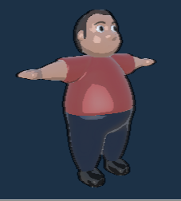

## *Name:* Shawn “Whiplash” Jenkins

*Description:* Known for his aggressive shopping style, Whiplash isn’t shy about reminding competitors of his nickname.

## 

*Name:* Erik “Ironsides” Dumont

*Description:* Revered in the market aisles for his steadfast cart riding, Erik earned himself the name Ironsides early in his career.

## 

## *Name:* Jada “The Bounty Hunter” Price

*Description:* Jada is no stranger to Sales Sunday. The Bounty Hunter is well known for her efficiency in finding the day’s best deals consistently!

## 

## 

## *Name:* Anne “Munitions” Foster

*Description:* Anne is a force of nature in grocery markets. Some say it’s magic, others say it’s skill, but she always seems to have another item to throw at her rivals.

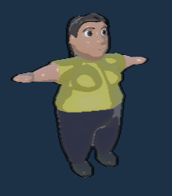

*Name:* Elena “La Campeona” García

*Description:* The reigning champion of Sales Sunday is returning this week for another shopping spree - watch out!

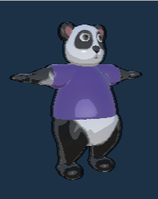

*Name:* Qiu “The Bamboomer” *Panda*

*Description:* Qiu is a feared panda in the competitive shopping scene due to the high impact tactics she often puts on display.

## 

## 

## *Name:* Reese “The Bandit” *Raccoon*

*Description:* Reese was invited to participate in Sales Sunday races after being observed deftly picking up grocery items others had dropped.

## 

## 

## 

## *Name:* Barty “The Horns” *Cow*

*Description:* Mess with Barty, and you’ll get The Horns. This cow is more of a bull during competition for the best sales!

## 

## *Name:* Jason “The Dragon” Forte

*Description:* Jason has been training his entire life in order to perform in Sales Sunday. After taking over international shopping events, he hopes to take his career to the highest level.

## 

## *Name:* Buck “The Headlight Buster” *Deer*

*Description:* Infamous for his nefarious past of destroying his opponents’ headlights, Buck is no stranger to high speeds - or big crashes.

## 

## 

## *6.5 Level Designs:*

Mini Mart: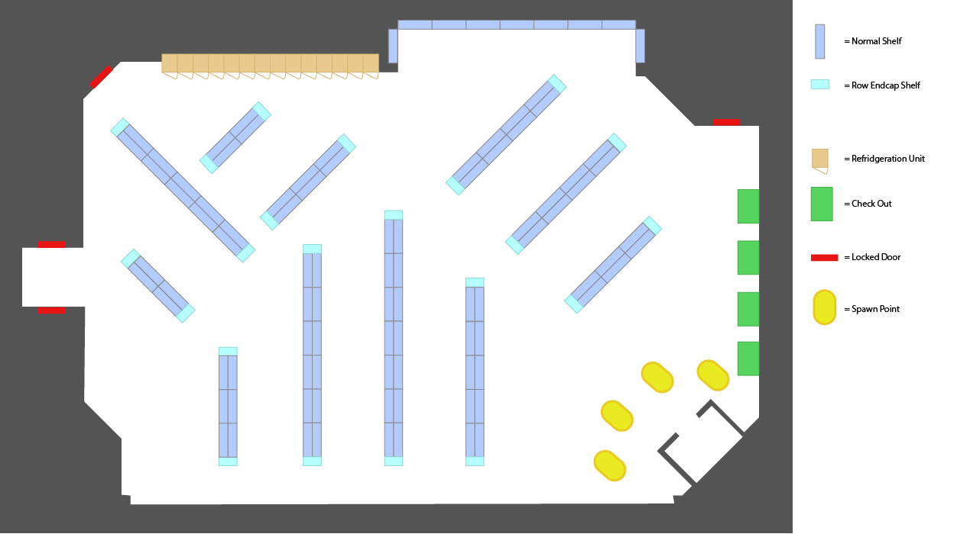

Circuit: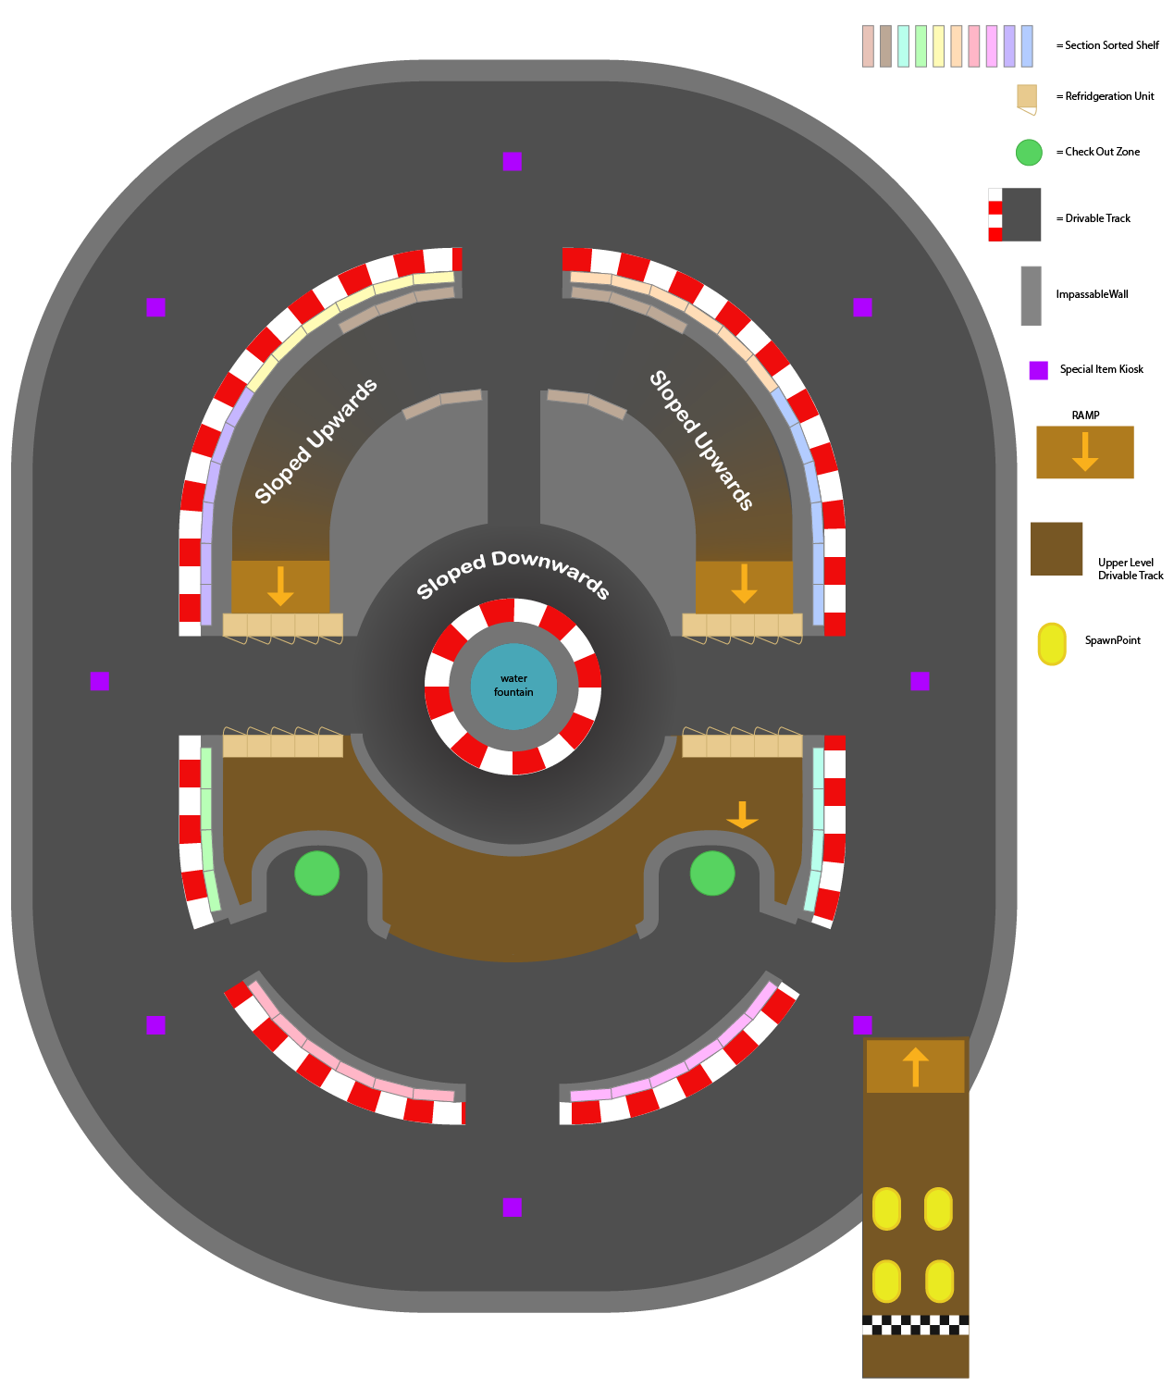

## *6.6 Achievements List:*

This list contains all the possible achievements and rewards one can accomplish

in Retail Rally. Achievements may sometimes grant the player a new character or shopping cart, or a new store layout! Unaccomplished achievements can be viewed via a tab in the main menu. However, some achievements are secret and players cannot view what is required of them to unlock it.

1. *Sheriff Marshall’s* Tell All

In the mini-mart, spill the beans.

Reward: Big Bean Character

1. Independent Shopper

In the mini-mart, check out 15 or more groceries.

Reward: Circuit Map

1. Aisle Hopper

In the mini-mart, explore every aisle in a single game.

Reward: Pirate Ship Cart

1. Crash Dummy

Collide with another player while both going at your top speed.

Reward: Crash Dummy Character

1. Spam Caller

In a single playthrough, send each of your opponents a robo-call.

Reward: Antenna Hat

1. No Use Crying

After throwing a gallon of milk, ride through it.

Reward: Cow Character

1. Slow and Steady...

Check out an item every thirty seconds in one game.

Reward: Turtle Character

1. Gang’s All Here!

Play a game of Retail Rally with 4 human players.

Reward: Robot Character

1. Part of This Nutritious Breakfast

Check out milk, cereal and fruit in one game!

Reward: Cereal Bowl Hat

1. No Refunds

Lose 5 groceries in a single game.

Reward: Dunce Cap

11. Speeding Violation

Hold top speed for fifteen seconds on any cart.

Reward: Simple Shopper TurboNitroV8

12.Royal Drifter

Drift 30 times in a single game.

Reward: Queen/King Crown

13.Tantrum

Throw 10 items in a single game.

Reward: Pacifier

14.Completionist

Check out every item at least once.

Reward: Alien Ship

15.Bigger Burger

Purchase Helping Hand-Burger.

Reward: Burger Cart

16.Inaccurate Shopper

Grab 10 items not on your shopping list.

Reward: Simple Shopper Vintage

17.Pedal to the Metal

Reach top speed 30 times in a single game.

Reward: Baghera Pedal Tractor

18.Sub-Par

Hit a robot with a thrown item.

Reward: Golf Cart

19.Sunday Driver

Complete 5 loops on the Circuit Map.

Reward: Lil Tykes Cozy Coupe

20.Kleptomaniac

Pick up items that other players have dropped 10 times.

Reward: Raccoon Character

21.Sedentary

Remain stationary for 30 seconds.

Reward: Panda Character

22.Biggest Fan

Purchase all 3 Martha Jean products in a single game.

Reward: Martha Jean Character

## *6.5 Tutorial Objectives:*

1. Reach Max Speed
2. Pick up an item
3. Throw an item
   1. Say something about lots of items doing something different
4. Switch items (using the phone)
5. Checkout an item
6. Get 30 score (buying items on your list)
   1. Leading up to this objective we have to describe the mechanics of the scoring system. Currently you get score by buying sales sunday marked items. You lose score by buying non-sales sunday items. The discount timer in the center of the screen represents a timer. Whenever the discount reaches 100%, the game is over. The amount of score obtained from sales sunday items gets greater the higher the discount.